Change Order Request

May 13, 2016

Chinn Construction, LLC
14715 NE 95th Street, Suite 101
Redmond, WA 98052
Attn: Charlie Poggemann

Re: Hadley Apartment Project – Change Order Request – ASI-024R Shower Changes

Charlie,

One Way Plumbing total cost to date for ASI-024R is $28,739 + 10% OH&P = $31,612. This includes all costs from the start of work on this ASI, until the close of business today, May 13, 2016. Please issue an official Change Order at your earliest convencience. Let me know if you have any questions or comments. Thank you.

Sincerely,
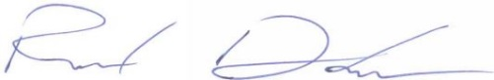
Richard Donelson
Project Manager / Estimator
LEED® Green Associate
richd@owpllc.net
425-591-4296 cell

